**2021 Officers & Directors**

**President**

Karen Olson, MAI

Vice President

Sarah Cunningham, SRA

Secretary/Treasurer

Dan Dvorak, MAI

**Directors**

Luke Wanninger, MAI

Clint Miller, MAI

Mike Cowan, SRA

Jared Gregory, SRA

Jonathan Westercamp, Candidate

Regional Representative

Jeremy Keller, SRA, AI-RRS

Committee Chairs

Gov’t Relations:

Dane Anderson, MAI

Candidate Guidance:

Chapter Executive Director

Shauna Gehring, SRA

(515) 419-6076

iachap@yahoo.com

**President’s Message**

Thank you to those of you that joined us on May 24th for our spring social and education course at the Big Grove Brewery in Iowa City. It was so nice to have an event again and see so many of you in person! For those that were not able to attend, we hope to see you at Novemberfest on November 3rd at Jasper Winery in Des Moines.

Our next class offering will be Uniform Appraisal Standards for Federal Land Acquisitions (Yellowbook) on September 9th and 10th in Urbandale. This is a great class for anyone that has an interest in or currently works with federal acquisitions.

On behalf of our chapter, I’d like to thank Jeremy Keller, SRA AI-RRS for his service and leadership as our Chapter President these past two years. We were finally able to honor him at the spring social in Iowa City. Jeremy will continue his volunteering in leadership as our new Regional Representative.

I am honored to serve as the 2021 president for the Iowa Chapter and look forward to working with members along with Vice President Sarah Cunningham, SRA; Secretary/Treasurer Dan Dvorak, MAI and our Board of Directors Luke Wanninger, MAI; Clint Miller, MAI; Mike Cowan, SRA; Jared Gregory, SRA; and Jonathan Westercamp, Candidate. We hope to continue our chapter’s focus of providing first-class education, which would not be possible without our Executive Director Shauna Gehring, SRA. Shauna does so much behind the scenes for our chapter and we thank you for your hard work especially through this last year.

Thank you to our membership for the support, grace and understanding as we have navigated through the last year. With 2020 behind us, I think we realize how important it is to belong to an organization that creates relationships. Please consider volunteering at some point during your appraisal career whether it is serving on a committee, board position or role in leadership. If anyone has any questions about serving or would like to volunteer, please reach out.

Karen C. Olson, MAI

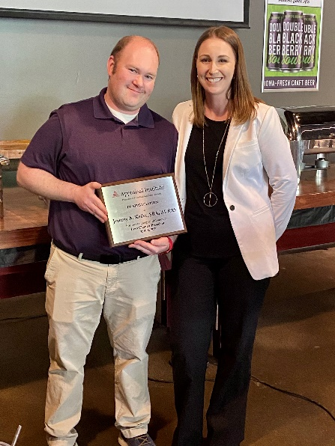

2021 Iowa Chapter Regional Representative Jeremy Keller, SRA/AI-RRS with 2021 Iowa Chapter President Karen Olson

**Regional Representative Comments**

It has been quite a past year and half and I am very proud of how our organization has moved forward despite the Pandemic.

On the Regional and National levels the AI is working on better diversity training and how to help move the profession forward. It is a very important topic now and National is looking at how we can be more inclusive.

We will be having our Annual Conference in Orlando this year after the one last year was unfortunately canceled and there will be an in person regional meeting just before this conference kicks off (August 8th) with the conference being August 9-10th.

Please reach out to me or Shauna or Karen or any of our executive board members if there is any concerns or questions you have for our region or for national. I am our connection and would love to ask any questions or pass on any information our chapter members have.

Jeremy Keller, SRA/AI-RRS

**New Designees**

The Iowa Chapter would like to congratulate the following for earning new Appraisal Institute Designations since the beginning of 2020:

|  |  |
| --- | --- |
| **Appraiser** | **Designation**  **Earned** |
| Kevin Kesterson, SRA | SRA |
| Douglas Steinkamp, MAI, AI-GRS | MAI |
| Rory Heims, MAI, AI-GRS | AI-GRS |
| Rory Heims, MAI, AI-GRS | MAI |
| Patrick D. Bodenhamer, MAI | MAI |
| David Mouw, MAI | MAI |
| Angela Snyder, SRA | SRA |
| Brian Thomas Velky, MAI | MAI |
| Chris R. Jenkins, MAI, AI-GRS | AI-GRS |
| Eric David Caldwell, MAI | MAI |

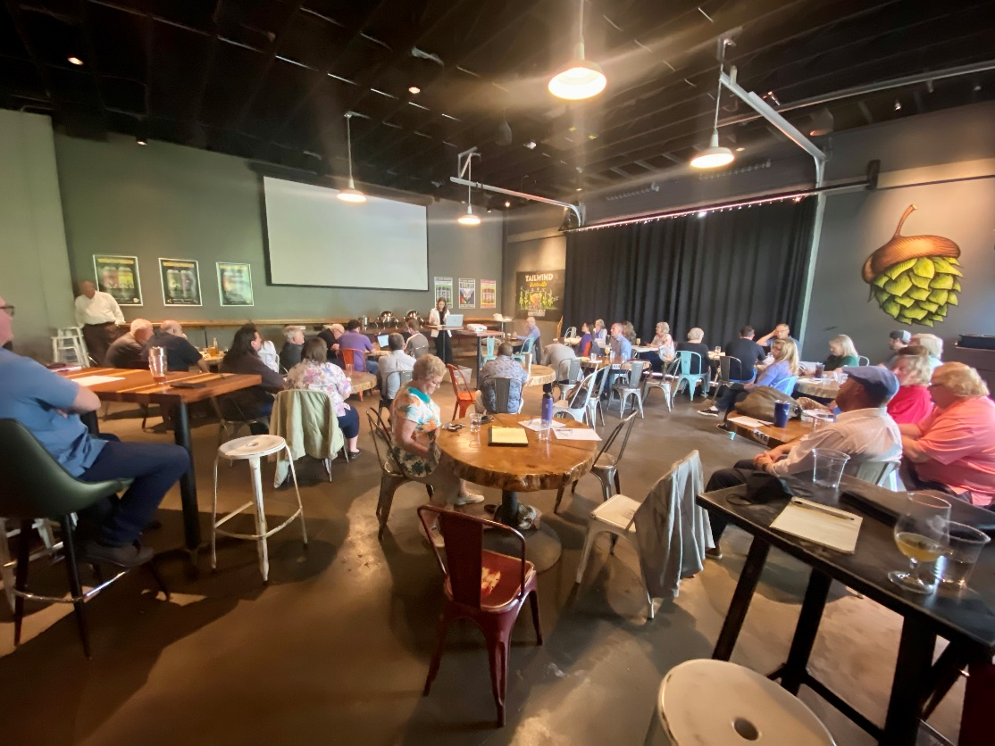

Springfest May 24, 2021

**Iowa Chapter Education 2021**

CE credit applied for: Appraisers (ILL & Iowa) Realtors & Assessors.

Registration is now open.

**Sign up at:** [**http://www.aiofiowa.org/Education/**](http://www.aiofiowa.org/Education/)

**September 9 and 10**

**Uniform Appraisal Standards for Federal Land Acquisition (Yellow Book) ((Classroom)**

**14-15 Hrs**

**Urbandale**

**Fee: $395**

_________________________________________________________________________________

**November 3rd**

**Novemberfest / Annual Social / Lunch /**

**Education: Artificial Intelligence, AVM’s & Blockchain ((Classroom)**  
4 Hrs  
Des Moines

Jasper Winery

**Fee: $140**

Click the link below for the Iowa Chapter's educational offerings:

<http://www.aiofiowa.org/Education/>

Click the link below for the National educational offerings:

[ai.appraisalinstitute.org/eweb/DynamicPage.aspx?webcode=AIEducationSearch&_ga=2.214063573.397798647.1605111752-1339147342.1601054760](https://ai.appraisalinstitute.org/eweb/DynamicPage.aspx?webcode=AIEducationSearch&_ga=2.214063573.397798647.1605111752-1339147342.1601054760)

